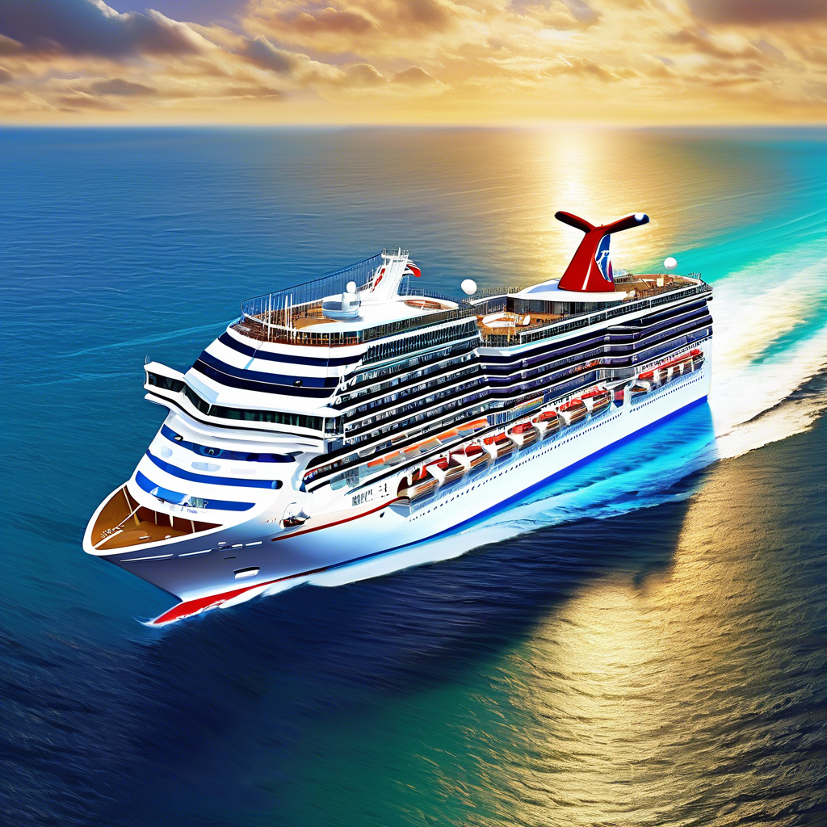 | We are excited to announce an unforgettable group cruise to the Eastern Caribbean in February 2026! Join Pack Your Bags Travel as we embark on a spectacular journey through stunning islands, where turquoise waters meet pristine beaches and vibrant cultures await. Whether you're seeking adventure or relaxation, this trip has something for everyone. Mark your calendars and get ready for an unforgettable experience in paradise! Cabins starting at $579. Scan QR code for additional details.

Carnival Magic Itinerary
Day 1: February 15 – Depart from Port of Miami
Day 2: February 16 – Fun Day at Sea
Day 3: February 17 - Amber Cove, Dominican Republic
Day 4: February 18 - Grand Turk
Day 5: February 19 - Celebration Key, Bahamas
Day 6: February 20 – Fun Day at Sea
Day 7: February 21 - Return to Port of Miami
Call Sheila Buettner  567-356-5023  Pybttravel.com |   Scan for Web site  and additional information

